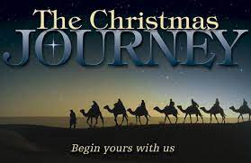
Prayer Spaces in Schools

Prayer Space Term 4 2021

Overview information

The Prayer Space is about journey, in particular about journeying to Christmas.

The Christmas Journey is made up of 8 stations. Please encourage and remind the students to be respectful of the space. The ideal would be that the students are broken into groups before they come to the Prayer Space, this enables the students to move more easily around the Prayer Space.

We are going to move into the Prayer Space
You will see there are eight Prayer Stations.
You will be broken into groups.
You will have a few minutes at each station then you will be asked to move to the next one.
Please be respectful of each other’s space by speaking quietly and not rushing around.
Your teacher and Chaplain are there to help you if needed.

The following stations can be visited while you are in the Prayer Space.

- What is God Like?
- Christmas Journey
- Missed Journey
- A Manger for a Bed: Saying sorry and Journeying on
- Journeying towards the star
- Who is invited to take the Journey
- Waiting on the Journey
- Peace for the Journey

Please talk with your students about the Prayer Space before you attend.
Also, talk about each station as students move to each station. Talk with them about respecting each other’s need for quiet reflection. It is not pass or fail situation, but rather a time to slow down and be still and think/reflect/pray.
In the following pages, you will find information about the Prayer Space.
If you have any questions, then please feel free to contact me. Rev’d Susan & Rev’d Jazz
Station 1: What God is like?
Props
-Gazebo with dark sides
-Table
-Dark table cloth
-Fairy lights
-Plasma ball
-Inspirational quotes
- Script

Who is God? What is God like? These are huge questions, and it's great to create space for students to consider these questions in their own way. Sometimes the best ways involve objects and things to touch and feel and engage with, as these inspire creative ideas. This simple activity encourages students to play with a plasma ball while considering what God is like.

The students are encouraged to think creatively for themselves about what God might be like, about how God might interact with them, and with the world- expect to be amazed by the answers and thoughts that are given, particularly the younger students.

Script
This activity encourages you to creatively think what God is like.
How does God interact with us?
How does God interact with the world?
Spend some time touching the Plasma Ball.
Watch how it reacts to the movement of your hands.
Maybe it reminds you of God.

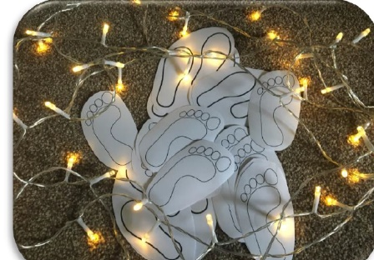
Station 2: Christmas Journey
Props
-Set up in Sanctuary
-Feet
-Basket for feet
-Large feet
-Felt pens
-Holder for felt pens
-Fairy Light Tree
-Inspirational quotes
- Script

In the Christmas story, Joseph and Mary travel at least 110 km (on a donkey!), from Nazareth to Bethlehem, where Mary has her baby. The wise men from the East traveled even further (probably by camels!), following a bright star all the way to Bethlehem. We can travel 100km in a couple of hours now, but in those days, it would have taken weeks.
Life is a journey, and we have all sorts of experiences along the way.
In this activity, the students are encouraged to reflect on their ‘journey’ through the past year. How did it begin? What’s happened along the way? What were the good moments? How do they feel about the next year of their life journey?
The students are invited to draw or write about an important moment in the past year, the good, and not so good or sad. And then they are encouraged to leave it behind and move into the next part of their journey. Once the student has finished, they take the foot and place the foot on the path.
Script
Mary and Joseph travel a very long journey from Nazareth to Bethlehem on a Donkey.
Our year at school is like a long journey, with lots of experiences.
What were some things that happened this year?
What was good about this year?
What was not so good or sad?
If you want, you can write or draw an important experience on one-foot print.
Place them on the path in the Sanctuary as a symbol of the journey ahead.

Station 3: Missed Journey
Props
-Two tables
-Two table clothes
-Small Stones
-Sand
-Sand Trays
-Fairy Lights
-Blu-tac
-Inspirational Quotes
-Bible Quote
-Script

Luke 2: 6-7 “While Joseph and Mary were in Bethlehem, the time came for her to have the baby. Mary gave birth to her first son. She wrapped him up well and laid him in a box where cattle are fed. She put him there because the guest room was full.”

As there were census in Bethlehem when Jesus was born all the inns were full, so the inn keepers that had said no to Joseph, missed out on being part of Jesus’ birth.

Script
Do you have any regrets, perhaps the way you’ve behaved in a situation or any opportunities that you may have missed out on because you didn’t want to get involved?
You are invited to take a stone and think of what you regret, the stone symbolises this. Push the stone into the sand and bury it, giving it to God.

Station 4: A Manger for a Bed: Saying sorry and journeying on
Props
-Gazebo
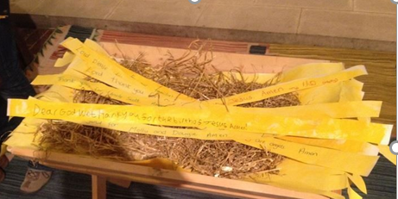
-Manger/basket
-Paper Strips
-Pictures of nativity
-Felt pens
-Felt pen holders
-Fairy Lights
-Blu-tac
-Inspirational quotes
-Script

Jesus was born in a manger because the innkeepers turned Mary and Joseph away. Sometimes people do and say unkind things to us. Sometimes we do and say unkind things. Have you done anything that you need to say sorry for? If you want to, you can write or draw a ‘sorry’ prayer onto the paper strip and place it in the manger as a symbol of offering this to Jesus, knowing that you are forgiven.

Script
Inn keepers turned Mary and Joseph away. When Jesus was born a manger (an animal trough) became his bed.
Have you been unkind or unfair to another person?
Have you done, said, or thought mean things about someone?
If you want to, take one piece of paper and write or draw what you are sorry for.
Take your paper and place it in the manger as a way of saying sorry.
Station 5: Journeying towards the star
Props
-Gazebo
-String
-Pegs
-2 Basket for pegs
-Stars
-2 Baskets for stars
-Fairy Light Tree
-Felt pens
-Felt pen holders
-Inspirational quotes
-Script

What are you most proud of this year? What have been your achievements this year? Where have you needed guidance and help? Maybe there were times when you wanted to give up. When the wise ones were trying to find the baby Jesus, they also needed help. They had guidance of a star that would help them find what they were looking for.
Perhaps you would like to say thank you! Maybe your parents, your teachers, or your friends have helped you. Perhaps you would like to say thank you to God for those people who have help guide you this year.

Script
Take a star and think about those people who have guided you on your journey this year. Think about the wise ones who were guided by a star in their journey towards Jesus. Perhaps you would like to thank God for those people who helped and guided you this year. Write or draw on a star the person or people who guided. Then peg the star onto the string.

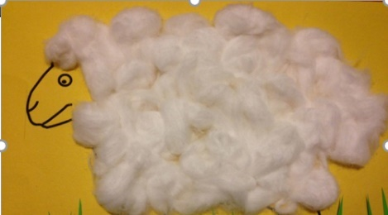
Station 6: WHO IS INVITED TO TAKE THE JOURNEY?
The Props
-2 white tables
-2 plastic clothes
-Grass
-Sheep outline
-2 Baskets for sheep
-Wool
-Glue sticks
-Pens
-Pen holders
-Fairy lights
-Inspirational quotes
-Bible Quote
-Scipt
The shepherds lived on the margins of society and yet God included them in God's plan. Not many people liked them, and often they were left out of things or forgotten. As we journey towards Christmas, no one should be left out. How do we care for those who are on the margins?
Script
You are invited to think of someone who doesn’t get involved in the games at lunchtime, someone who possibly feels left out or on the edges of life in school. Write their name in the middle of the sheep then using the glue stick the wool over the name, decorating the sheep.
As you finish this activity, ask yourself, how can you be kind and reach out to those on the edges? If you want to, ask God for help.
Luke 2:8-11 ‘And there were shepherds living out in the fields nearby, keeping watch over their flocks at night. An angel of the Lord appeared to them, and the glory of the Lord shone around them, and they were terrified. But the angel said to them, “Do not be afraid. I bring you good news that will cause great joy for all the people. Today in the town of David a saviour has been born to you; he is the Messiah, the Lord.’

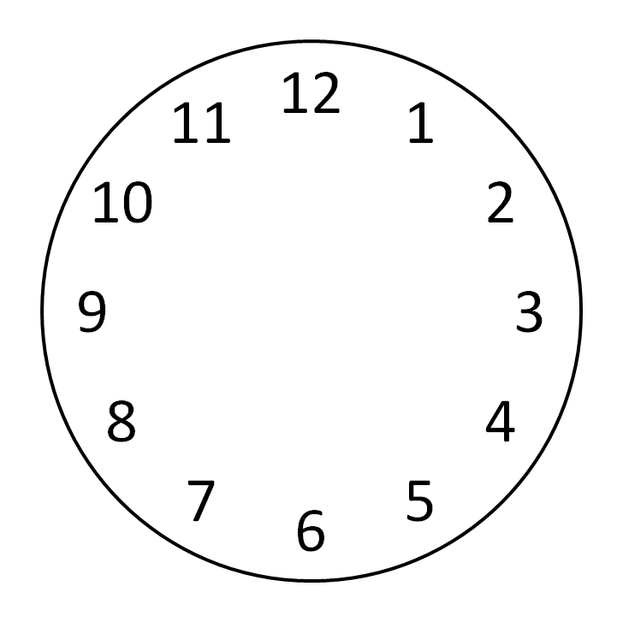
7. WAITING ON THE JOURNEY
Props
-Paper clocks
-Basket and baby
-Fairy lights
-Pens
-Pen holders
-Inspirational quotes
-Bible reading
-Script

Students are being encourage to think and reflect about what they may be waiting for this Christmas. What are they looking forward to. For some students, this station maybe about learning to bring things to God and trust in God's timing.

Script
Is there something you are waiting for this Christmas? Whether that’s presents, seeing family or maybe welcoming baby Jesus.
Take a clock and write or draw what you are waiting for on the clock and lay the clock in the crib.

Luke 2: 25-26 ‘Now there was a man in Jerusalem called Simeon, who was righteous and devout. He was waiting for the consolation of Israel, and the Holy Spirit was on him. It had been revealed to him by the Holy Spirit that if he waited, he would see the baby Jesus.’

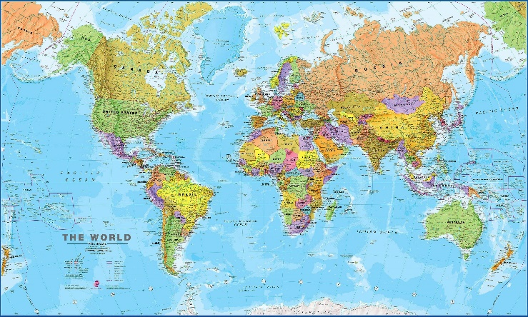
Station 8: Peace for the Journey
Props
-1 white table
-World Map
-Tiny stones
-Bowls
-Blu-tac
-Inspirational quotes
-Article about war, famine etc.
-Script

There are many places in the world where people live in fear and have no peace due to war, famine, disease, COVID and persecution.

Script
Think about a particular place in the world. You may have heard about people who may be persecuted because of their beliefs, you might have seen something in the articles in this station, or you may have heard something on the news or your family talking about it.
Take a stone and place it on the country where you think needs our prayers and thoughts.

